**“If else” condition in pyton**

The "if" condition is a fundamental control structure in programming that allows you to execute certain blocks of code based on whether a specific condition is true or false. It enables you to control the flow of your program by making decisions dynamically during runtime.

**If condition is true it enters the block.**

**If condition is false it jump to next statement.**

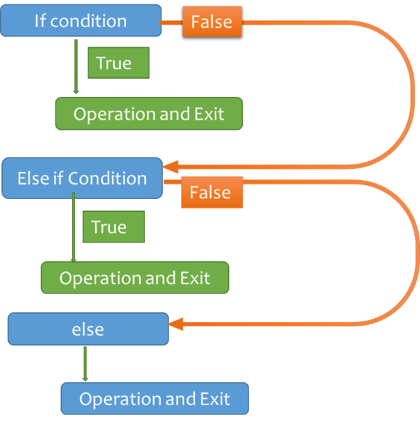

**Loops:**

**While Loop**

A while loop in Python is used to repeatedly execute a block of code as long as a specified **condition is true** and stopswhen the condition becomes **false.**

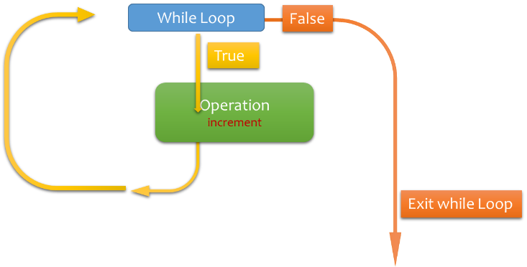

**For Loop**

A for loop in Python is used to iterate over a sequence (such as a list, tuple, string, or range) or any iterable object. It allows you to execute a block of code multiple times, once for each item in the sequence.

Once the **Range is over** loop stops.

